# Aim

To implement computer graphics algorithms for drawing a line, circle, and ellipse using Python (matplotlib).

# Code

**:**

**import matplotlib.pyplot as plt**

**import numpy as np**

**from collections import deque**

**W, H = 300, 300**

**board = np.ones((H, W, 3), dtype=np.uint8) * 255**

**def connect_points(points):**

**for i in range(len(points)):**

**x1, y1 = points[i]**

**x2, y2 = points[(i + 1) % len(points)]**

**line_plot(x1, y1, x2, y2)**

**def line_plot(x1, y1, x2, y2):**

**dx, dy = abs(x2 - x1), abs(y2 - y1)**

**x, y = x1, y1**

**stepx = 1 if x2 > x1 else -1**

**stepy = 1 if y2 > y1 else -1**

**if dx > dy:**

**err = dx // 2**

**while x != x2:**

**board[y, x] = [0, 0, 0]**

**err -= dy**

**if err < 0:**

**y += stepy**

**err += dx**

**x += stepx**

**board[y, x] = [0, 0, 0]**

**else:**

**err = dy // 2**

**while y != y2:**

**board[y, x] = [0, 0, 0]**

**err -= dx**

**if err < 0:**

**x += stepx**

**err += dy**

**y += stepy**

**board[y, x] = [0, 0, 0]**

**def fill_area(sx, sy, target, new):**

**tgt = np.array(target, dtype=np.uint8)**

**if sx < 0 or sx >= W or sy < 0 or sy >= H:**

**return**

**if not np.array_equal(board[sy, sx], tgt):**

**return**

**q = deque([(sx, sy)])**

**while q:**

**cx, cy = q.popleft()**

**if cx < 0 or cx >= W or cy < 0 or cy >= H:**

**continue**

**if np.array_equal(board[cy, cx], tgt):**

**board[cy, cx] = new**

**q.append((cx + 1, cy))**

**q.append((cx - 1, cy))**

**q.append((cx, cy + 1))**

**q.append((cx, cy - 1))**

**shape = [(60, 60), (240, 60), (190, 210), (110, 240), (60, 160)]**

**connect_points(shape)**

**fill_area(150, 120, [255, 255, 255], [0, 128, 255])**

**plt.imshow(board)**

**plt.axis('off')**

**plt.show()**

# Output

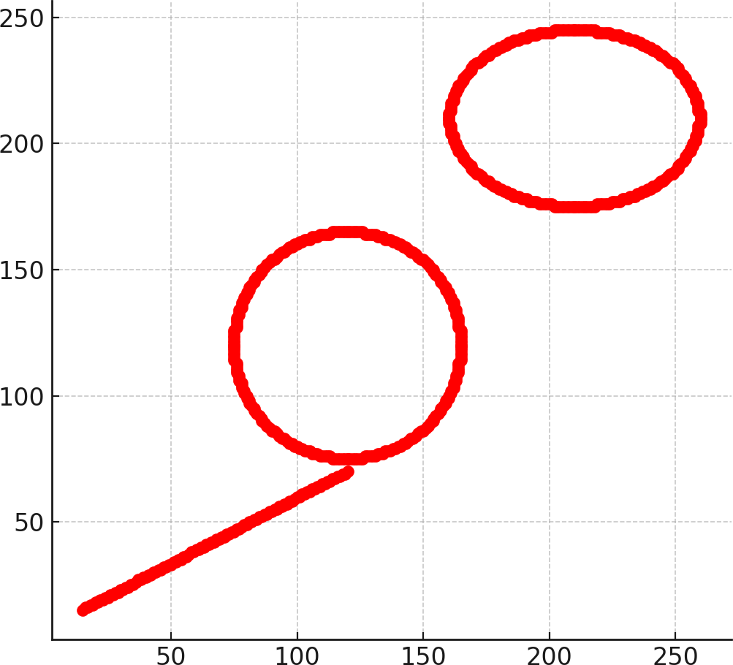

**Conclusion**

The experiment successfully demonstrates the implementation of basic computer graphics algorithms in Python. Using Bresenham’s line algorithm, midpoint circle, and midpoint ellipse algorithms, we can

efficiently rasterize geometric primitives without relying on built-in graphics functions.